SEA GAMES LOGO

2 x 2 Picture
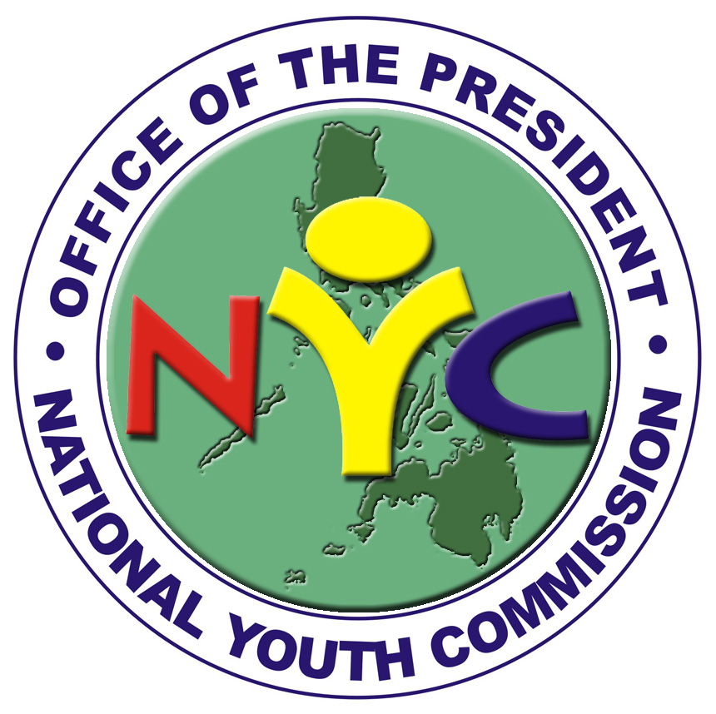 |  |  | Volunteers’ Program
APPLICATION FORM
PERSONAL INFORMATION

Name

Last Name First Name Middle Name Nickname
Date of Birth |  |  |  | Civil Status |  |  | Age |  | Gender M / F |  |  | Nationality
Home Address

Telephone / Fax |  |  |  |  |  |  | Cellphone
Profession / Occupation |  |  |  |  |  |  | Email
Office / Organization and Address

Volunteer Work Experience (Use additional sheets if necessary)
Volunteer Work |  |  |  |  |  | Type of Involvement |  |  | Date and Place |  |  |  |  | No. of hours

Please Indicate Available Schedule (Specific dates, time and area for volunteer work for the year)

Qualifications:  Must be at least 15 to 35 years of age  - Physically/mentally fit  - Excellent work attitude  - Committed and dedicated to work  - Pleasant disposition |  |  |  |  |  |  |  | Documents Required:  - Two (2) Copies of Completed Volunteer’s Application Forms with two (2) pieces of latest  “2 x 2” pictures  - Comprehensive RESUME / Curriculum Vitae  To include: education, work experience (max 2 pages)  - Certificate of Good Moral Character  (from School/organization/employer)
Please check field of volunteer work/interest
 |  | Community dev’t./organizing |  |  | Arts and culture (acting, singing, dancing, etc) |  |  |  |  |  | research
 |  | Legal expertise |  |  | Information Technology/ Computer
 |  | Health (doctors, nurses, etc) |  |  | Environment
 |  | Communication/Media |  |  | Education/Training
 |  | Sports and Recreation Others, please specify: _________________

Statement of Waiver and Attestation

I hereby attest that all information indicated herein are true and correct to the best of my knowledge.

Furthermore, I voluntarily accept the risks and assume all responsibilities from any untoward incident that may arise in the duration of my involvement as Volunteer to NYC Volunteers’ Program.

_____________________________________
Signature Over Printed Name
___________________________
Date Accomplished
NOTE:
You can mail, hand carry or email your applications to the:

NYC Volunteers’ Program Secretariat
4/F Bookman Building, 373 Quezon Avenue, Quezon City, Philippines
Telephones (02) 781 1406, (02) 781 1613, (02) 749 9401, (02) 749 9404, (02) 781 1162,
Fax (02) 781 2323 EMAIL: www.youth.net.ph and volunteer@youth.net.ph

